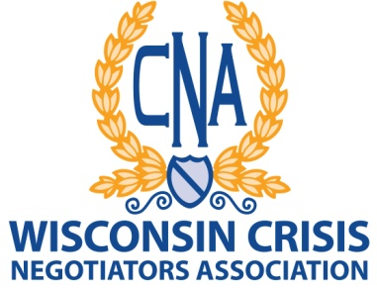

All awards should be nominated by active members, with an application to be filed with the Awards Committee. The application may be submitted anytime but remember the Awards are presented at the yearly conference so timely applications are important. The application will then be evaluated by the Awards Committee for completeness and authenticity. Recommendations will be forwarded to the Board of Directors for approval. All awards will be presented at the next annual conference by the President or a designee.

AWARDS CATEGORIES

Crisis Negotiator of the Year. Awarded to the member that goes above and beyond normal duty in a crisis negotiation, or contributes greatly beyond the normal scope to the area of crisis negotiations.

Medal of Honor Winner. Awarded to a member for bravery beyond that of the members normal duties which subjected the member to a risk of personal injury or death.

Meritorious Service Award. Awarded to a group of members or a team of negotiators from a department or from assisting departments who demonstrates the highest degree of professionalism in their respective positions during an incident.

Distinguished Service Award. Awarded to a member who is about to retire from the law enforcement profession and has shown the highest degree of professionalism during that member’s career.

Public Service Award. Awarded to an associate member or non-member in appreciation and recognition for assisting law enforcement in such a manner that was highly instrumental in the conclusion of a successful negotiation.

Memorial. Awarded to the family of a member who has passed. Also the member’s name would be added to the Association’s Official memorial plaque.

Awards Coordinator:
Nancy Irizarry
E-mail: nancy.irizarry@dhs.wisconsin.gov

